QUANTUM WOLF

DATA INTELLIGENCE & RESEARCH LAB

DATE:05-03-2025 TO 07-03-2025

NAME:ABDUL ZUHAIL M

**Report: Dynamic Grid Management System**

**Problem Statement**

The use of renewable energy sources like solar and wind in power grids is challenging because their energy production is unpredictable. Changes in weather can cause energy generation to vary, leading to mismatches between the energy available and the energy needed. Without a proper system to handle these changes, extra energy is often wasted, and shortages can cause power outages. Additionally, the inability to monitor and optimize energy use in real-time leads to financial losses, inefficiencies, and a greater dependence on non-renewable backup energy sources.

**Solution**To address these challenges, we propose a Dynamic Grid Management System. This system uses advanced technology to:

1. Predict: Accurately forecast how much energy will be generated (from sources like solar and wind) and how much will be needed, using past and real-time data.
2. Optimize: Store extra energy when production is high and release it when needed, ensuring less energy is wasted.
3. Monitor: Track energy usage in real-time, allowing quick detection and resolution of any problems.

By balancing energy supply and demand, reducing waste, and responding to changes instantly, this system creates a more stable, efficient, and sustainable power grid. It not only lowers costs but also helps shift toward cleaner, renewable energy sources.

**Overview**The Dynamic Grid Management System addresses the challenges of using renewable energy by:

1. **Predicting Energy Demand and Supply:** Using smart tools to estimate how much energy will be produced (from sources like solar and wind) and how much will be needed.
2. **Balancing the Power Grid:** Keeping the grid stable by avoiding situations where there’s too much or too little energy.
3. **Reducing Energy Waste:** Making sure extra energy is stored and used efficiently, so less is wasted.
4. **Real-Time Monitoring:** Providing live updates and insights to help make quick, informed decisions.

This system ensures a stable, efficient, and sustainable power grid, lowers costs, and supports the use of clean, renewable energy.

**Required Extensions**

Before executing the workflow, ensure the following Orange extensions are installed. These extensions can be downloaded and installed directly from **Orange’s Add-ons Manager**:

**How to Install:**

1. Open Orange3.
2. Go to **Options** > **Add-ons...**
3. Search for the required extensions and click **Install**.

**Extensions Needed:**

* **Orange3 (Base installation):** Core functionality for data analysis.
* **Orange3-Associate:** For data processing and transformation.
* **Orange3-Text:** For handling text-based data (if required).
* **Orange3-Timeseries:** For time-based energy predictions and analysis.
* **Orange3-Data:** For advanced data manipulation.

**Step-by-Step Process**

**1. Data Preparation**

**Objective:** Prepare raw energy data for analysis and modeling.

**Steps:**

1. **Data Collection:**
   * Import the energy-related dataset (generated using ChatGPT) containing details like energy generated, demand, temperature, and wind speed using the CSV File Import widget.
2. **Data Cleaning:**
   * Use the Impute widget to handle missing values and correct errors in the dataset, ensuring the data is accurate and reliable.
3. **Feature Selection:**
   * Identify and select the most relevant features (e.g., energy generation, weather data) using the Select Columns widget to focus on the key factors influencing energy supply and demand.
4. **Data Transformation:**
   * Convert categorical data into numerical format using the Continuize widget to make the data suitable for analysis and modeling**.**
5. **Feature Engineering & Advanced Processing:**
   * **Extract Time Features:** Use a Python Script widget to extract useful time-based features (e.g., hour of the day, week of the year) from the timestamp column.
   * **Aggregate Energy Generation:** Use another Python Script widget to compute energy generated over specific time periods (e.g., 7 days, 6 days) to identify trends in energy production and consumption.

**Widgets Used:**

* **CSV File Import:** Loads the dataset into Orange.
* **Select Columns:** Selects relevant attributes for analysis.
* **Impute:** Handles missing or incorrect data.
* **Continuize:** Converts categorical data into numerical format.
* **Python Script:** Performs advanced processing like time feature extraction and energy aggregation.
* **Data Table:** Displays the processed data for review.

This structured process ensures the dataset is clean, organized, and ready for accurate analysis and modeling.

**Output**:

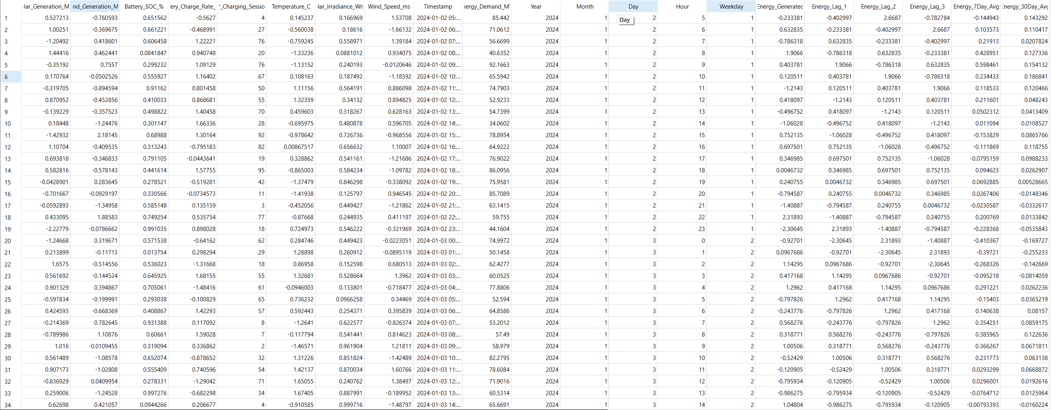

**2. Forecasting Energy Supply & Demand**

**Objective:** Predict future energy generation and consumption using historical data.

**Steps:**

1. **Data Splitting:**
   * The dataset is divided into training and testing subsets. The training data is used to teach the model, while the testing data evaluates how well the model performs on unseen data.
2. **Model Training:**
   * Machine learning models are trained to recognize patterns in historical energy generation and consumption. These models learn from past data to predict future energy needs and supply.
3. **Model Evaluation:**
   * The accuracy of the predictions is assessed using evaluation metrics like accuracy, precision, and recall. This step ensures the model is reliable and effective.

**Widgets Used:**

* **Data Sampler:** Randomly splits the dataset into training and testing parts.
* **Random Forest:** An ensemble model that combines multiple decision trees to improve prediction accuracy.
* **Tree:** A decision tree model that identifies relationships between input variables (e.g., weather, time) and energy demand/supply.
* **Gradient Boosting:** A boosting algorithm that combines weak models into a stronger, more accurate predictive model.
* **Neural Network:** A deep learning model that captures complex patterns in energy data for more precise predictions.
* **Test and Score:** Evaluates the model's performance using metrics like accuracy, precision, and recall.

This process ensures accurate predictions of energy supply and demand, helping to balance the grid and reduce waste.

**Output:**

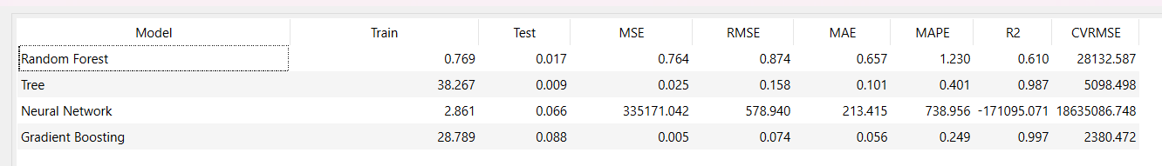

**3. Optimizing Energy Use**

**Objective**: Identify strategies to store excess energy and optimize consumption patterns.

**Steps:**

1. **Feature Filtering:**
   * Use the Select Columns widget to choose the most relevant features that influence energy storage and consumption, such as energy generation, demand, and weather conditions.
2. **Pattern Identification:**
   * Apply the K-Means clustering algorithm to analyze energy usage trends and detect patterns. The clustering results can be interpreted as:
     + **C1 (Blue):** Represents well-balanced states where energy generation and consumption are aligned.
     + **C2 (Red):** Highlights inefficient usage patterns or anomalies, such as energy shortages or excess waste.
     + **C3 (Green):** Captures transitional states where energy demand and generation fluctuate but are not extreme.
3. **Data Aggregation:**
   * Use the Aggregate Columns widget to summarize energy data, such as calculating average energy consumption over time. This provides actionable insights for optimizing energy use and storage.

**Widgets Used:**

* **Select Columns:** Filters and selects the most relevant energy-related features.
* **K-Means:** Performs clustering to identify patterns in energy usage.
* **Aggregate Columns:** Summarizes energy data to generate insights for decision-making.

This process helps identify strategies to store excess energy, reduce waste, and optimize consumption patterns, ensuring a more efficient and sustainable energy system.

**Output:**

**Scatter Plot:**

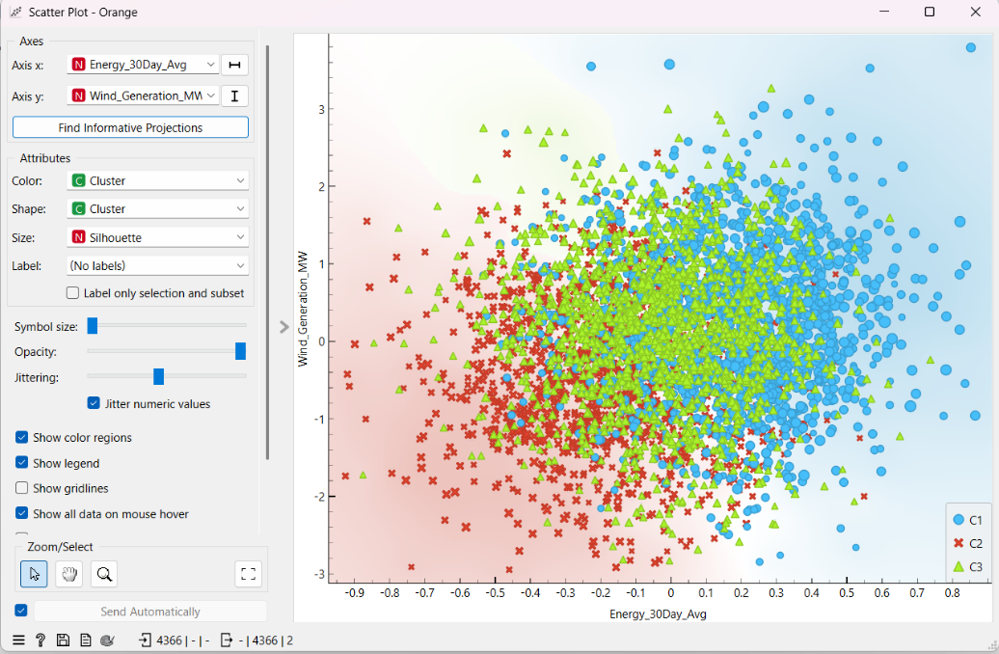

**4. Real-Time Monitoring**

**Objective**: Visualize energy trends and detect anomalies for proactive grid management.

**Steps:**

1. **Trend Analysis:**
   * Use the Line Chart widget to display energy usage and generation trends over time. This helps identify seasonal or daily patterns, such as peak demand hours or periods of high energy production.
2. **Relationship Analysis:**
   * Use the Scatter Plot widget to examine correlations between energy demand and external factors like temperature or weather conditions. This helps understand how these factors influence energy consumption and generation.
3. **Anomaly Detection:**
   * Use the Box Plot widget to detect outliers and anomalies in energy data. This flags sudden spikes or drops in energy production or consumption, enabling quick responses to irregular patterns.

**Widgets Used:**

* **Line Chart**: Visualizes energy trends over time.
* **Scatter Plot:** Highlights relationships between energy demand and external factors.
* **Box Plot:** Identifies outliers and anomalies in energy data.

This real-time monitoring process ensures proactive grid management by providing clear insights into energy trends, relationships, and anomalies, helping maintain grid stability and efficiency.

**Output:**

**Line Chart:**

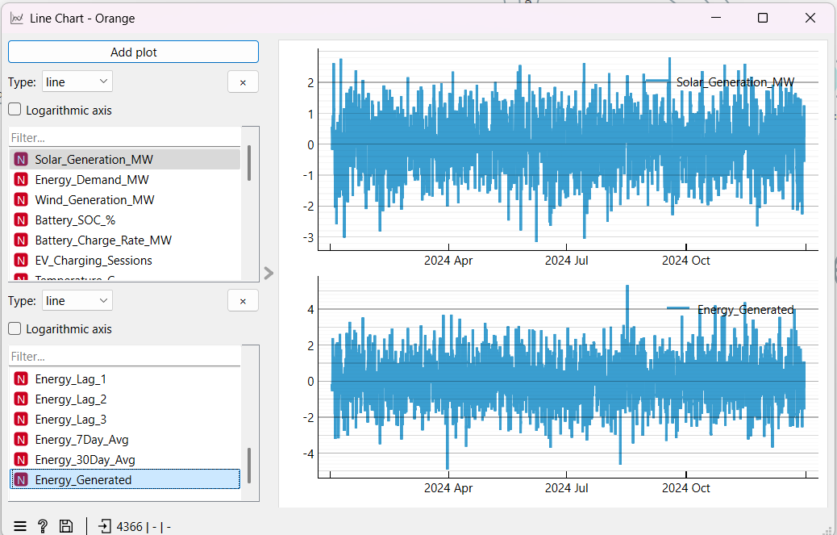

**Scatter Plot:**

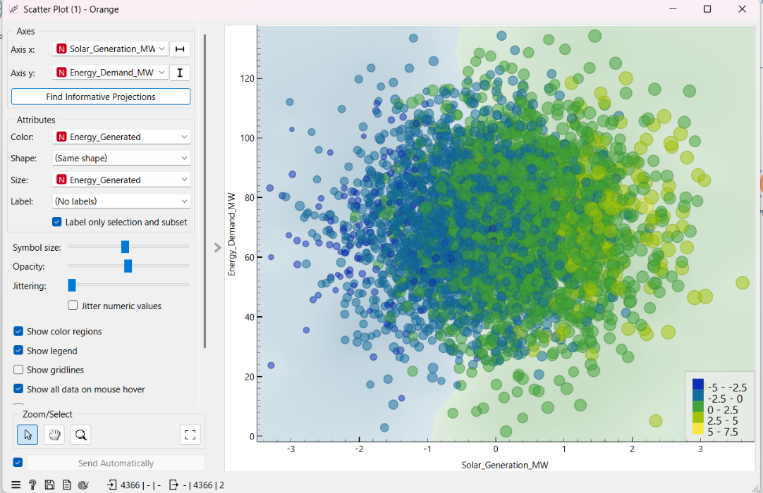

**Box Plot:**

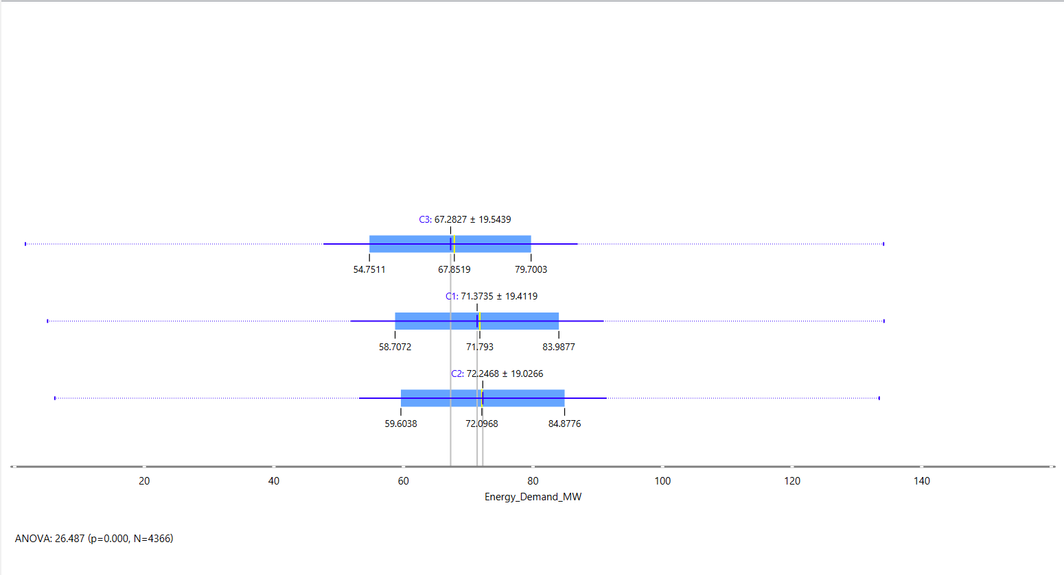

**5. Final Evaluation**

**Objective:** Measure the accuracy of predictions and refine the system for continuous improvement.

**Steps:**

1. **Feature Ranking:**
   * Use the Rank widget to identify and rank the most influential factors affecting energy prediction, such as weather conditions, time of day, or energy generation trends. This helps prioritize key variables for future analysis.
2. **Data Visualization:**
   * Use the Data Table widget to display the final processed dataset in a clear and structured format. This ensures transparency and makes it easy to interpret the results.
3. **Data Storage:**
   * Use the Save Data widget to store the refined dataset for future reference, analysis, or external use. This ensures that insights and predictions can be revisited and improved over time.

**Widgets Used:**

* **Rank:** Identifies and ranks the most important features in the dataset.
* **Data Table:** Displays the final processed data in a structured and interpretable format.
* **Save Data:** Stores the refined dataset for future use.

This final evaluation step ensures the system’s predictions are accurate, transparent, and continuously improved, supporting long-term grid stability and efficiency.

**Output:**

**Rank:**

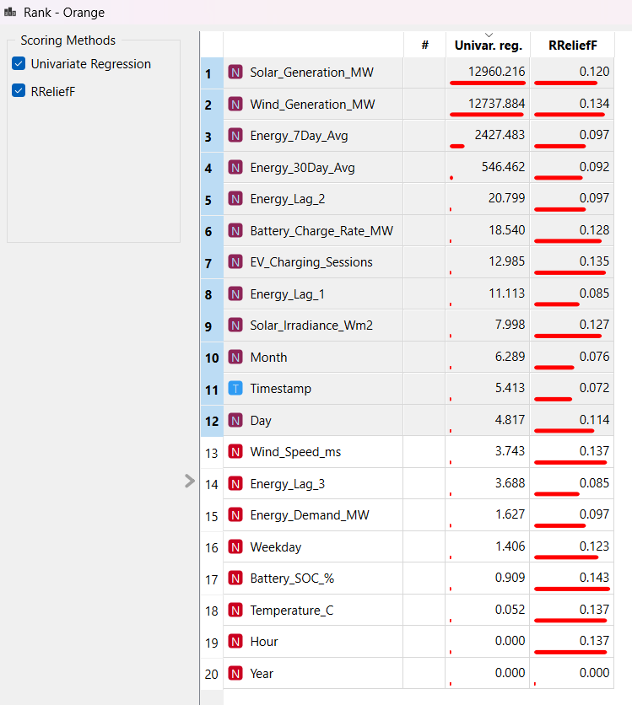

**Final Output:**

The system delivers the following key outcomes:

1. **Insights on Energy Production and Demand:**
   * Accurate predictions of energy generation and consumption enable effective planning and resource distribution, ensuring the grid meets demand without overloading.
2. **Reduced Energy Waste:**
   * Optimization techniques ensure excess energy is stored or redirected efficiently, minimizing waste and maximizing the use of renewable resources.
3. **Improved Grid Stability:**
   * Real-time monitoring allows for quick identification and response to fluctuations in supply and demand, maintaining a stable and reliable power grid**.**
4. **Actionable Recommendations:**
   * Data-driven insights provide power companies with clear, strategic recommendations for sustainable energy management, helping them make informed decisions for long-term efficiency and reliability.

These outcomes create a more efficient, stable, and sustainable energy system, supporting the transition to renewable energy while reducing costs and environmental impact.

**Output:**

**Workflow Environment:**

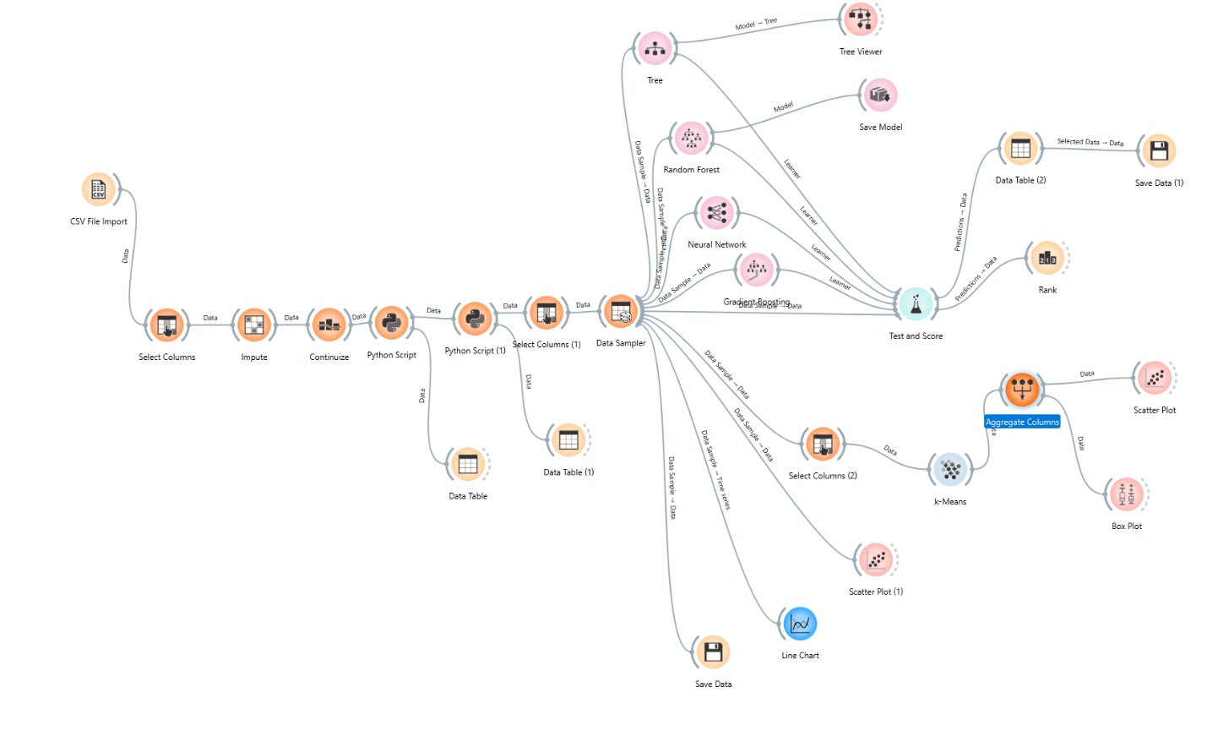

**Challenges Faced and Solutions Implemented:**

1. **Problem:** Some required nodes were missing in Orange, making it difficult to perform advanced tasks.  
   **Solution:** We used Python scripting to extend functionality, enabling tasks like time feature extraction and data aggregation.
2. **Problem**: Training large datasets was challenging due to limited computational resources.  
   **Solution:** We optimized the dataset by focusing on key features and used efficient algorithms like Random Forest and Gradient Boosting to balance accuracy and computational efficiency.
3. **Problem:** Managing real-time predictions and optimizing grid performance in dynamic conditions remains a challenge. **Solution:** We designed the system to be scalable by integrating real-time monitoring tools and cloud-based solutions, improving its ability to handle dynamic data and provide timely insights.

These solutions helped address the challenges, ensuring the system delivers accurate predictions, reduces energy waste, and supports sustainable energy management.

**Conclusion:**

The Dynamic Grid Management System is a powerful and innovative solution for efficiently managing renewable energy. By combining data processing, machine learning, and real-time monitoring, the system delivers significant benefits:

* **Cost Reduction**: Minimizes operational costs by reducing energy waste and optimizing resource allocation.
* **Enhanced Reliability:** Ensures a stable and reliable power grid by balancing supply and demand in real-time.
* **Sustainability:** Promotes the use of renewable energy sources, reducing reliance on non-renewable energy and contributing to environmental sustainability.

This system not only addresses the challenges of integrating renewable energy into the grid but also paves the way for a cleaner, more efficient, and sustainable energy future.